Soft Condensed Matter Physics
Dr Nigel Wilding (3West 2.8(A), N.B.Wilding@bath.ac.uk)
Course web page: http://staff.bath.ac.uk/pysnbw/SOFT.bho/soft.html

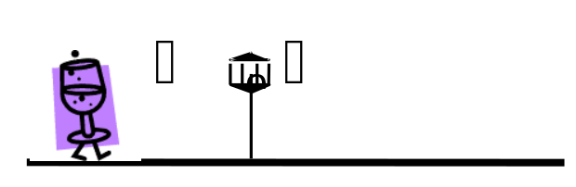 | - Introduction and overview
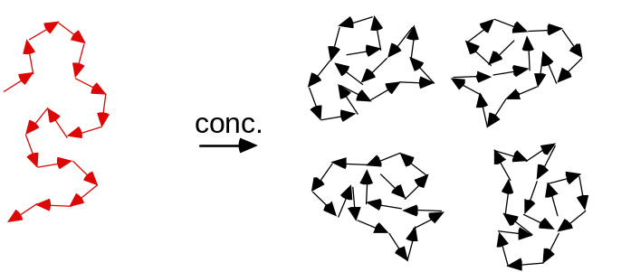 | Part 1: COLLOIDS  (2) Brownian motion  (3) Interacting colloidal suspensions
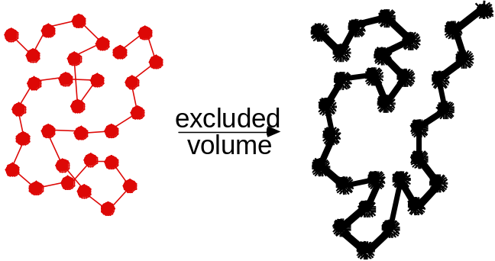 | Part 2: POLYMERS  (4) Chemical structure  (5) Polymer conformations  (6) Concentrated polymer solutions
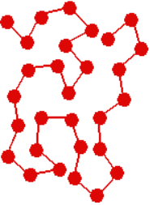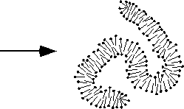 | Part 3: SURFACTANTS  (7) Chemical structure  (8) Self-assembled structures
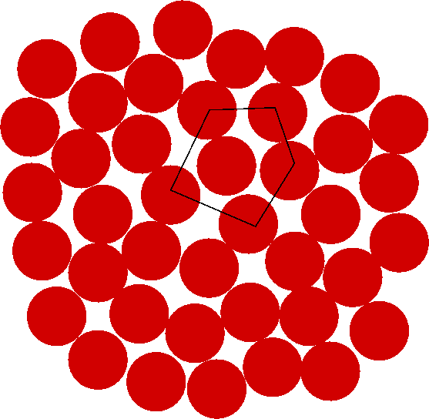  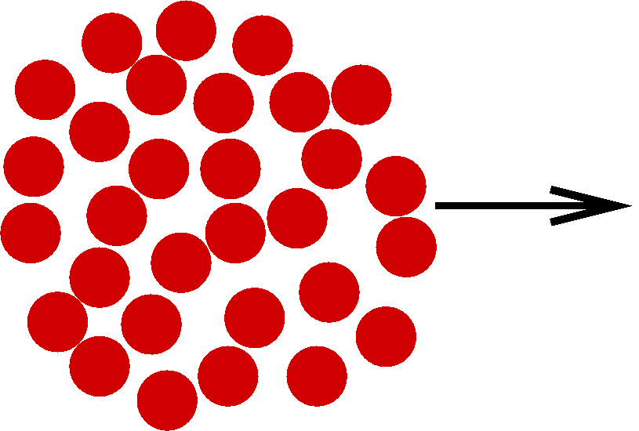 | Part 4: GLASSES  (9) Glass forming systems  (10) Relaxation time and viscosity

(1) Introduction and overview
Soft condensed matter physics, or macromolecular physics, or the physics of complex fluids, is the study of colloids, polymers and surfactants. All these systems contain structural units in the colloidal length scale, 1nm <R <1 µm.

  - Systems and definitions

• A colloid consists of a disperse phase (solid, liquid or gas 'particles') distributed in a finely divided state in a dispersion medium (solid, liquid or gas 'solvent').

disp.  medium  disp.  phase | solid | liquid | gas
solid | solid suspension:  pigmented plastics, stained glass, ruby glass, opal, pearl | sol, coll.susp.:  metal sol, toothpaste, paint, ink, clay slurries, mud | solid aerosol:  smoke, dust
liquid | solid emulsion:  bituminous road paving, ice cream | emulsion:  milk, mayonnaise, butter, pharma-ceutical creams, digestion | liquid aerosol:  fog, mist, tobacco smoke, hair spray
gas | solid foam:  zeolites, expanded polystyrene, 'silica gel' | foam:  froths, soap foam, fire-extinguisher | -

• A polymer is a large molecule made up of many (hundreds to millions) repeats of a single subunit ('monomer'). It is kept together by covalent chemical bonds. Different architectures exist: linear-chain homopolymers, (block) copolymers, starpolymers, dendrimers etc. We concentrate on linear chains, which also represents the main building block of the other structures. Examples: polyethylene, cellulose, DNA, proteins.
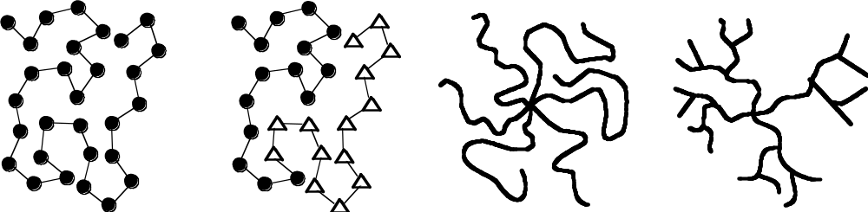

• A surfactant (SURFace ACTive AgeNT) is a special kind of molecule. In the simplest case, it has a water-loving (hydrophilic) 'head group', and a water-hating

(hydrophobic) 'tail'. Above a certain concentration they spontaneously self-assemble into a wide variety of structures, the simplest being a spherical micelle. They associate by (rather weak) physical interactions ('association colloids'). Examples: Sodium Dodecylsulfate (SDS), lipids.

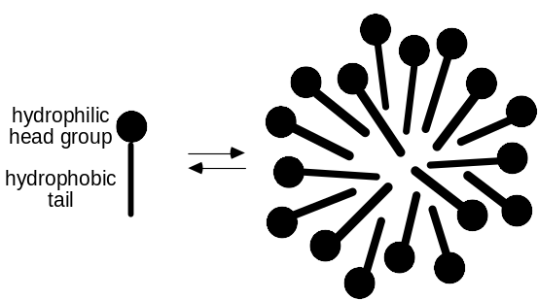

Note: In general, when in bulk form, the substance forming colloidal particles is quite insoluble in the dispersion medium. However, when the bulk material is broken down into very small pieces it can be dispersed. Such a system is called a lyophobic ('solvent-avoiding') colloid. Some colloidal particles themselves consist of polymers or surfactant assemblies which can easily be dispersed and are thus labelled lyophilic ('solvent-loving'). Mostly when we talk about “colloids”, we do not care about the 'internal' structure of the particles, while we are in general interested in the structure of polymers or surfactant assemblies.

• Many liquid-state soft matter system, particular colloids and polymers can be cooled to very low temperatures without crystallizing. At these low temperatures, the typical relaxation times of the particles becomes very high, even on experimental time scales. Thus the liquid-like disorder is “frozen-in” and we refer to the system as a glass.

1.2 Macromolecules: principal distinguishing features

1.2.1 Size Range (1nm <R <1 µm)
Lower limit (about 1 nm): This ensures that the size of the dispersed particles is much larger than the size of the molecules forming the dispersion medium. This not only distinguishes colloids from ordinary (true) solutions, but also results in a 'well-defined' interface between the particles and the surrounding medium. Furthermore, (most of the time) this allows us both, to treat the dispersion medium as a continuum and to avoid quantum mechanics.

Upper limit (about 1 µm):
• Balance of thermal and potential energy:
Every particle has thermal energy Etherm = (3/2) kBT and potential energy
Epot = mgz = (4π/3) R3Δρgz, where z is a characteristic length, e.g. R, and Δρ is the density difference between the particle and the dispersion medium. For a significant influence of the thermal energy we need Epot < Etherm and thus for a typical system (Δρ ≈ 0.3 g cm-3): R < (9kBT / 8πΔρ g)1/4 ≈ 1 µm.

1.2.2 Sedimentation:

Gravity will lead to sedimentation of the suspended particles (or creaming, if the density of the particles is lower than the density of the dispersion medium) and to the formation of a dense sediment.
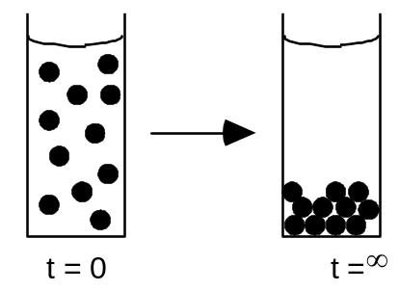

The sedimentation velocity vsed results from the balance of gravity and hydrodynamic drag:

gravity:
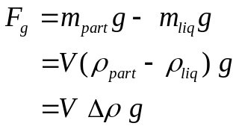
↓ sphere
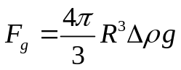
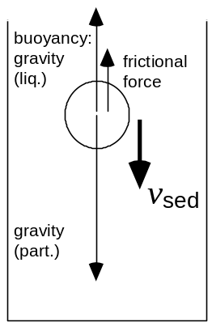
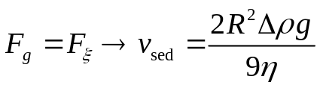

friction (Stokes law):
↓ sphere
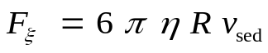

where m is the mass and ρ the density of the particle (part) and liquid (liq), respectively, Δρ the density difference, V the volume and R the radius of the particle, η the viscosity, v the sedimentation velocity and g the acceleration due to gravity.

1.2.3 Brownian motion and random walks
Random collisions with the liquid molecules cause the particle to change its direction of motion rapidly (resulting in 'mixing' the sample). This can be modelled as a random (drunk!) walk of N steps of length b with a random angle between the individual steps. How far from the origin does the particle get in N steps?
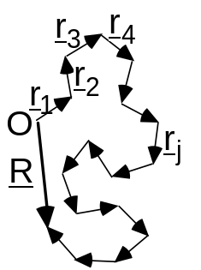

Average over many tries (or many particles):
<R> = = 0 since rj can be in any direction
Mean square displacement:
<R2> = <R·R> = < · > =
j = k: <rj · rk> = <rj2> = b2
j ≠ k: <rj · rk> = b2 <cosθ> = 0 since any θ in 0 <θ <2π
<R2> = = Nb2 ∝ t since time t ∝ N
In fact a more careful treatment shows that the root mean-square displacement <R2>1/2 = ∝ where for spherical particles the diffusion constant D = kBT/6πηR, where R is the particle radius.

Example: Consider uncharged protein spheres in water (ρprotein = 1.35 g cm-3) at 20°C (η = 1 Ps). We can calculate the displacement due to Brownian motion and sedimentation respectively as a function of the particle radius R.

For Brownian motion, we have 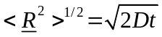 with 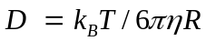
For sedimentation, we have 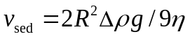
Hence we can make a plot of displacement versus particle radius.

R | D (20°C) | (<R2>)1/2 after 1h |  | vsed × 1h
1 nm | 2.1·10-10 m2/s | 1230 µm | > | 2.8 nm
10 nm | 2.1·10-11 m2/s | 390 µm | > | 0.3 µm
100 nm | 2.1·10-12 m2/s | 123µm | > | 30 µm
1 µm | 2.1·10-13 m2/s | 39 µm | < | 3 mm
10 µm | 2.1·10-14 m2/s | 12 µm | < | 0.3 m

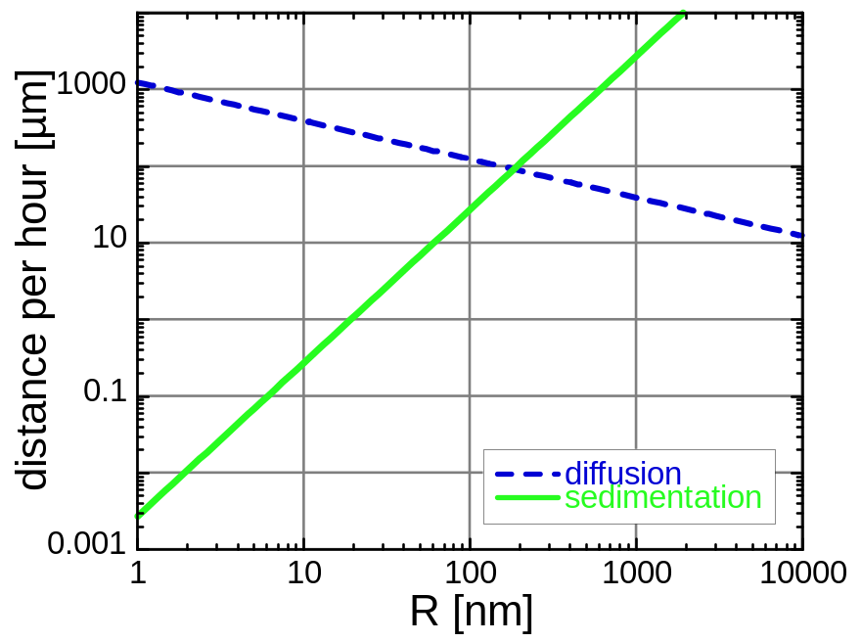

More generally we can write down equations which express the probability of finding a particle at a given vector displacement from its starting point. In the limit of a large number of random steps, one finds that in 1 dimension this probability is given by
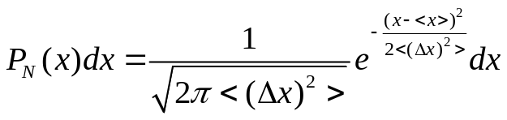 A 1d Gaussian distribution
This has mean 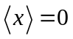and variance 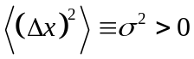.

In 3 dimensions, the corresponding relation is
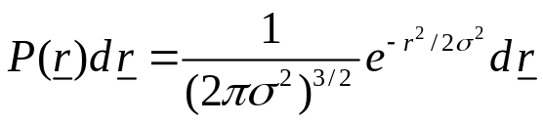 A 3d Gaussian distribution

The distribution has its first moment at the origin and second moment
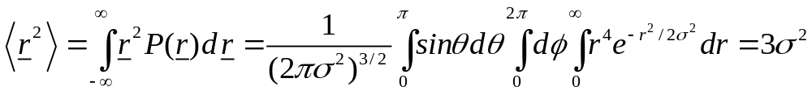

This latter result can also be obtained in a direct calculation, considering N random steps in x direction, N in y direction and N in z direction with 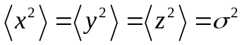 and thus 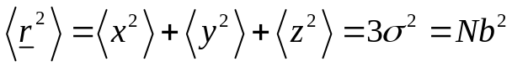

1.2.4 Large interface between dispersed phase and dispersion medium
In commercial terms it is often highly desirable to produce soft matter systems whose (chemical) properties lie somewhere between those of bulk and molecularly dispersed systems, i.e. whose properties are not just the sum of the contributions from the molecules in the bulk phases. To achieve this, a significant proportion of the molecules should lie within or close to the particle-medium interface, which is equivalent to a large surface-to-volume ratio ('microheterogeneous' systems, link to surface science).
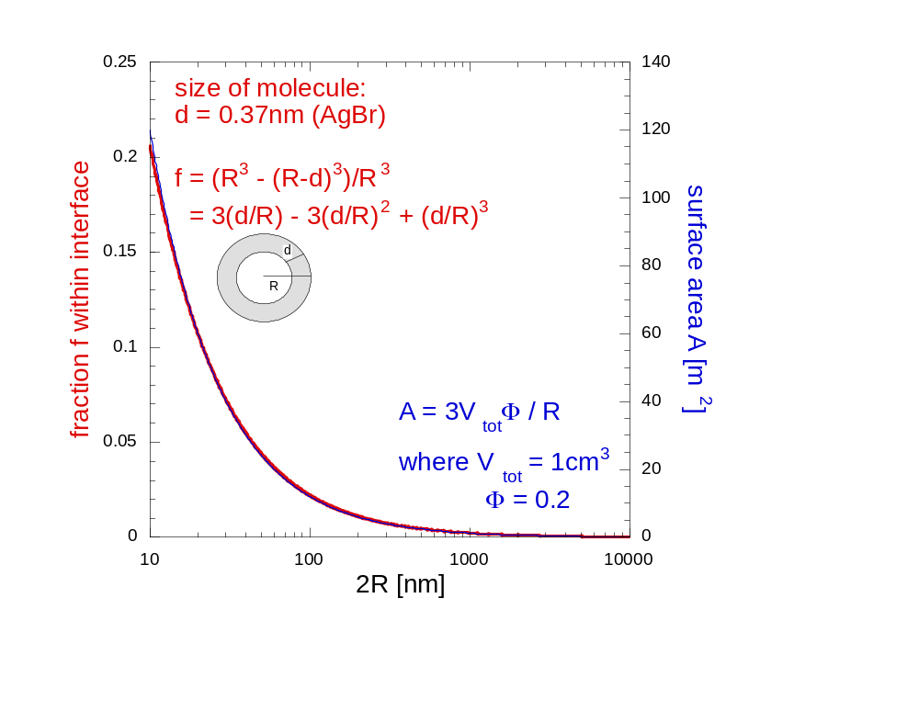
Often colloidal particles have a spherical shape, which allows for a relatively small surface-to-volume ratio, but they may also be ellipsoids (prolate or oblate), discs, rods, fibres, random coils etc.

1.3 Making measurements: Scattering experiments
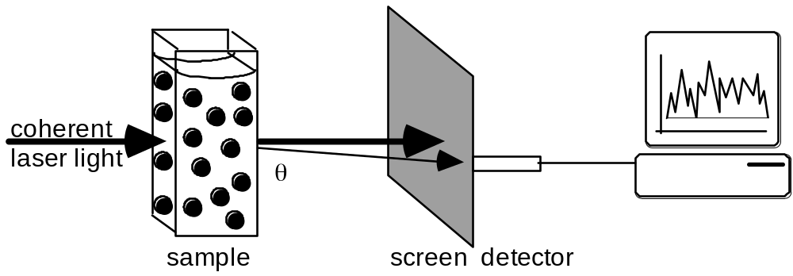
The most commonly used experimental tool for studying soft matter systems is scattering. The experiment may utilize light, neutrons or X-rays as the scattering probe. Due to the random arrangement of particles, a random diffraction pattern is observed. This fluctuates as particles move in Brownian motion. The scattered intensity as measured under a certain scattering angle will thus also fluctuate with time (given the detector area is small enough).
Part 1: COLLOIDS

(2) Brownian Motion

Brief history:
1828 Scottish botanist Robert Brown observed irregular motion of pollen grains suspended in water.
~1880 Many accepted that Brownian motion was associated with the nature of heat, but no quantitative theory
1905 Brownian motion explained by Albert Einstein
1926 Nobel Prize in Physics: Jean Baptist Perrin for investigations on Brownian motion (sedimentation equilibrium and mean square displacement) in connection with reality of molecules, linking Gas constant and Avogadro's number which led to the acceptance of the 'molecular hypothesis'.

2.1 Diffusion
Idea: So far we considered a single particle and calculated the probability for finding it after N steps in the volume element dr centred at r. We found that 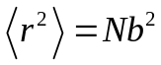, which suggests 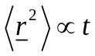 .
Now we are interested in many particles, where each undergoes a random walk and is not influenced by the others. We then ask: What fraction will be in a certain volume element after time t? This is the process of diffusion, e.g. spread of a drop of colour ink in water.

Mathematics: Suppose that the distribution of particles n(x,t) is not uniform. This non-equilibrium situation will lead to a motion of particles (diffusion) tending to increase entropy and restore a homogeneous concentration.
We are interested in the time-dependent concentration (number per unit volume) profile of particles n(x,t). In the case of an initially very narrow spatial distribution of particles this will correspond to the probability of any particle having moved to x.
The mean number of particles crossing unit area of a plane (perpendicular to the x-axis) per unit time (i.e. the 'flux'), is denoted by Jx. This flux is expected to be (to a good approximation) proportional to the concentration gradient:
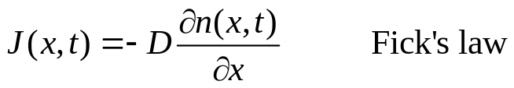
where the diffusion constant (or coefficient) D has been defined as the constant of proportionality

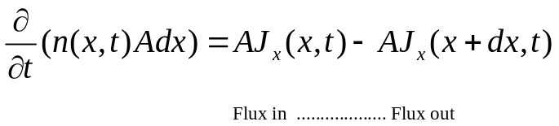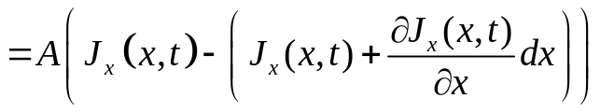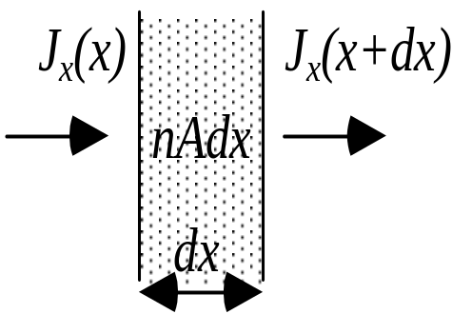Now, conservation of particle number demands

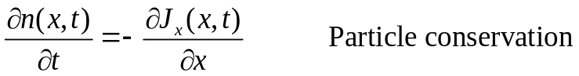and thus

Fick's law and particle conservation together give (assuming D ≠ D(x)):
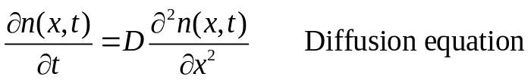

The solution, up to a constant C, which satisfies the initial condition (t=0) of having all the particles close together at x=0 is
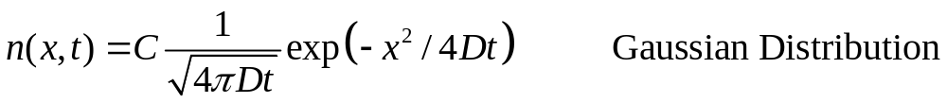
The constant C can be determined by 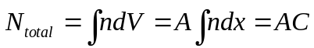. Hence

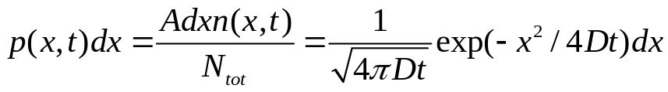
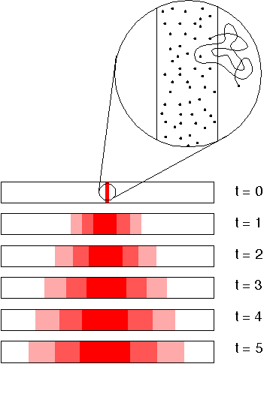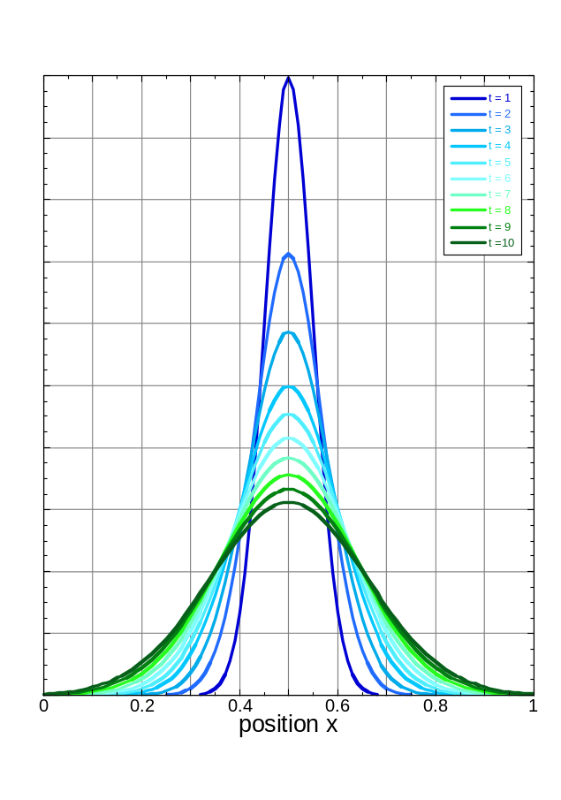
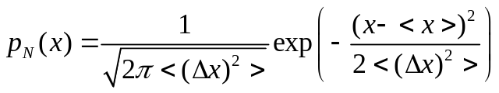But the spreading of the particle distribution with time is due to the random walk of individual particles, for which we already have an equation (1-D):
Comparing the result from the two points of view and setting <x> = 0, we get

<Δx2> = 2Dt
As expected the mean square displacement increases linearly with time, but we have now found the constant of proportionality: 2D.
Generalisation to three dimensions yields:
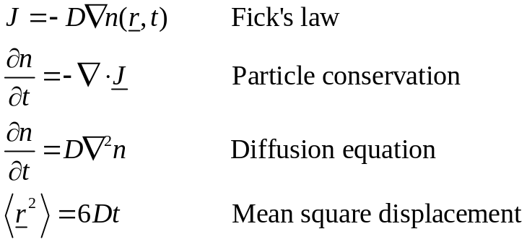

This last relation could constitute an alternative definition of the diffusion coefficient, instead of Fick's law.

2.2 Stokes-Einstein relation
Suppose that the particles are subjected to an external force F in the x direction, e.g. gravity. In thermal equilibrium the Maxwell-Boltzmann distribution is valid, i.e. the particle density n(x) is given by
where we assumed a constant force F in the last equation. In the case of gravity
F = m_{B}g with m_{B} the buoyant mass. n(x) results from the balance between the motion of the particles due to the external force setting up a concentration gradient, and the resultant diffusion given by Fick's law.

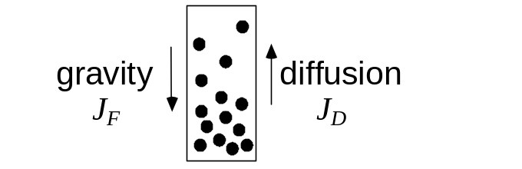In the case of gravity, this leads to a sedimentation equilibrium.

(a) Flux due to external force, J_{F}
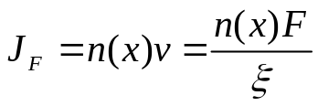The velocity of a particle under an applied force F in a viscous fluid can be written as v = F/ξ which defines the friction coefficient ξ. Hence

(b) Diffusive flux, J_{D}
J_{D} is given by Fick's Law (see above):

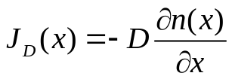

Equating the two fluxes J_{F} = J_{D} we get

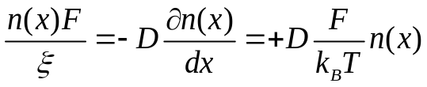

The second equation is obtained by differentiating the Maxwell-Boltzmann distribution. This gives the relation between the diffusion and friction coefficients:
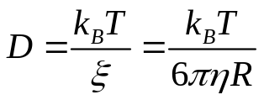
The last equation applies to a spherical particle of radius R in a fluid of viscosity η, for which Stokes’s Law gives ξ = 6πηR (which applies only at low Reynold's number, ρRv/η << 1) resulting in the Stokes-Einstein relation.

• The Stokes-Einstein relation is a very deep result. It relates equilibrium fluctuations in a system to the energy dissipation when the system is driven off equilibrium. Here, the fluctuations in the fluid give rise to the diffusive motion of the suspended particle and D is therefore the 'fluctuation' part. A sheared fluid will dissipate energy because of its finite viscosity and thus η represents the dissipative part.
• More generally, Brownian motion sets a natural limit to the precision of physical measurements. Example: A mirror suspended on a torsion fibre reflects a spot of light onto a scale. The spot will jiggle due to the random impact of air molecules and the random motion of atoms in the quartz fibre. To reduce the jiggle, the apparatus has to be cooled. The relation between fluctuation and dissipation tells us where to cool. 'This depends upon where [the mirror] is getting its 'kicks' from. If it is through the fibre, we cool it ... if the mirror is surrounded by a gas and is getting hit mostly by collisions in the gas, it is better to cool the gas. As a matter of fact, if we know where the damping of the oscillations comes from, it turns out that that is always the source of the fluctuations.' (Feynman, Chapter 41)

(3) Interacting colloidal particles

So far we have dealt with colloidal particles as independent spheres suspended in a medium. Now we will study concentrated suspensions in which interparticle interactions cannot be ignored.

3.1 Samples: model hard-sphere colloids
To be specific let us discuss a monodisperse colloid made up of polymethyl-

methacrylate (PMMA; perspex in bulk form) spheres, which are covered with polymeric hairs (Poly-hydroxystearic acid) to stop them sticking to each other. They show to a very good approximation hard sphere behaviour.

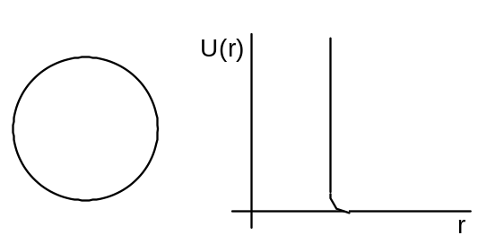

The radius of the colloid is typically 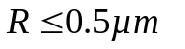with a very small polydispersity (size variation) of 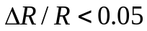.
The usual way of referring to particle densities is the 'volume fraction' φ, defined to be the fraction of the suspension occupied by particles. If we have N monodisperse spheres with radius R in the total volume V, then

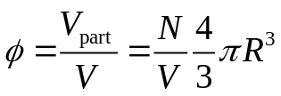

3.2 Phase Behaviour
As a reminder we first look at the interaction potential and phase behaviour of a simple atomic substance, such as argon. A generic inter-particle potential U(r) exhibits the infinite hard sphere repulsion as well as an attractive part of depth ε. The
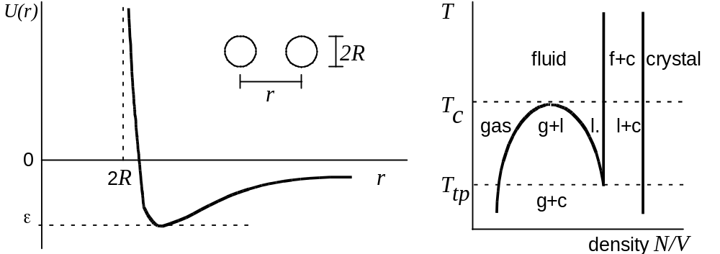
corresponding generic phase diagram in the temperature-density plane shows the regions where gas, liquid, fluid and crystal exist. A rough estimate of the critical temperature Tc is given by kBTc ~ ε. If ε → 0, as in the case of hard spheres, we expect that there will be no critical point and therefore no liquid phase. This is indeed the case.

Phase behaviour of hard-sphere colloids:
At very low densities, the structure of a hard-sphere suspension is like that of a perfect gas; the positions of the colloidal particles are practically uncorrelated and the chance of finding a particle in any particular vicinity is almost independent of the presence of all the other particles.

Upon an increase in particle density, their positions begin to become correlated as the

particles are mutually excluding. If we look inside a suspension of volume fraction φ ≥ 0.3, then we will find that, at any one instant, each particle is surrounded by a `cage’ of neighbours (short-ranged order). The cage tightens as φ increases. The cage size represents a dominant length scale in the system.
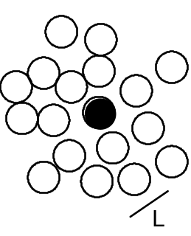

Despite the appearance of correlations between particle positions, a hard-sphere suspension below φ <0.5 is still in what one might call a 'colloid fluid' phase, i.e. the arrangement of particles in such a suspension is analogous to the arrangement of atoms in an atomic fluid (e.g. fluid argon) - on average the particle centres are more or

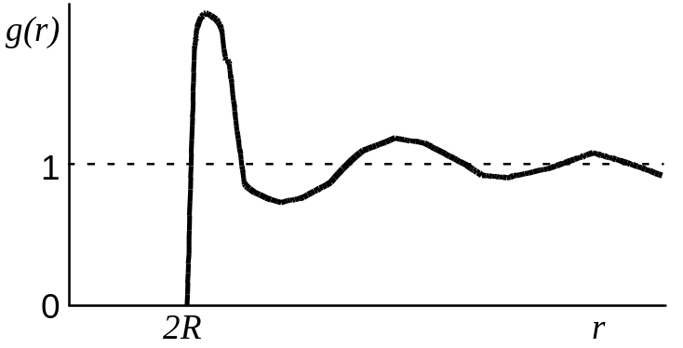

less randomly arranged, and each particle can, given time, wander through the available volume. The structure is described by the radial distribution function g(r). Given a particle centred at r = 0, (N/V)g(r)dr is the number of particles in dr at a distance r.

If we increase the volume fraction above φ ≈ 0.55, however, a phase transition occurs. The particles will spontaneously pack into a crystalline arrangement. Particles now can only move round about their average lattice site, but will not wander throughout the available volume. This phase is called a 'colloidal crystal'. Due to more local freedom the crystal has a higher (!) entropy than the metastable fluid from which it grows. It is an entropically-driven phase transition. Between φ=0.5 and φ=0.55, we find coexistence between colloidal fluid and crystal.
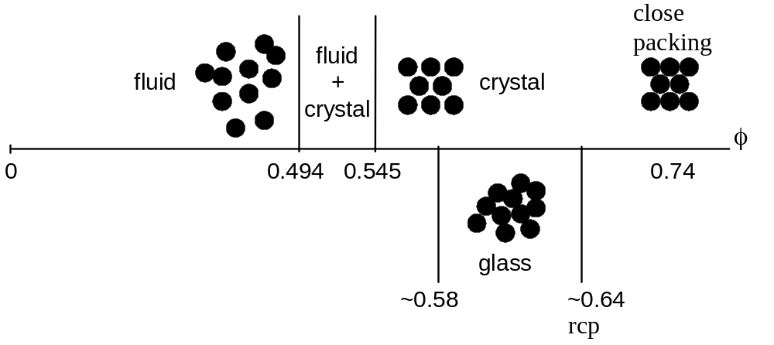
Note that no colloidal liquid is formed (Tc = 0), as expected for an interaction potential without attraction.
At the highest particle concentrations (above φ ≈0.58) crystallization may be avoided if the temperature is quenched very rapidly, and a colloidal glass is formed. We will return to study the behaviour of glasses in Part 4.

3.3. Particle dynamics

Hard-spheres
We are interested in the mean-square displacement <r2(t)> as a function of time for different volume fractions. At low volume fractions, the particles undergo Brownian motion (random-walk diffusion) due to collisions with liquid molecules. The mean-square displacement <r2(t)> = 6D₀ t as already seen earlier.
Above φ ~ 0.3, however, different regimes are observed. At short times the particles diffuse with the short time (self) diffusion constant Ds. This is determined from the

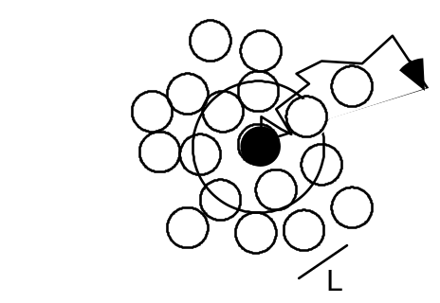
short time limit and is smaller than the D0 measured for φ → 0. The motion of the particles (self diffusion) is still driven by collisions with the liquid molecules, but in addition the interactions between particles become significant. While the particles are diffusing in their cages formed by their neighbours, the hydrodynamic interaction

with the neighbours, transmitted through flows in the liquid, causes slowing down relative to the free diffusion at low concentrations. At intermediate times the particles encounter the neighbours and the interactions slow the motion down. To make further progress, the particle has to break out of the cage formed by its neighbours. Now the particles experience a further interaction, direct interactions (hard-sphere interactions), in addition to the hydrodynamic interactions. The long-time and long-ranged movement is also diffusive, i.e. we still have <r2(t)> ∝ t, when the particles undergo large-scale random-walk diffusion through many cages. However, the motion is further slowed and a smaller diffusion constant relative to the motion in the short time limit is observed, the long time (self) diffusion constant DL.

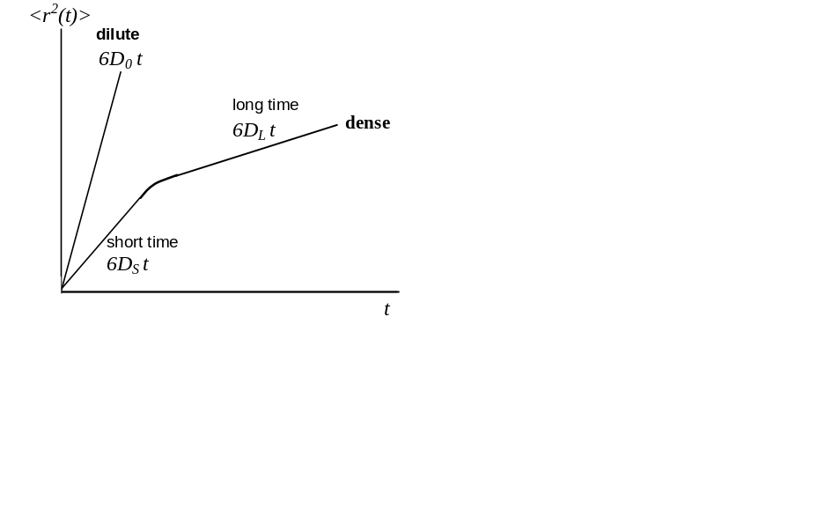
short time:  <r2(t)> = 6DS t  short-time self diff. coeff.  DS < D0 purely because of  hydrodyn. interactions  theoretical predictions exist | intermediate time:  some theory | long time:  <r2(t)> = 6DL t  long-time self diff. coeff.  DL < DS (< D0) because of  hydrodyn. and direct interactions  theory very complicated, but  some predictions exist

Part 2: Polymers

(4) Chemical structure

A polymer is a large molecule made up of many small, simple chemical units, joined together by chemical bonds. The basic unit of this sequence is called a 'monomer', and the number of units in the sequence is called the 'degree of polymerisation'. It is possible to have polymers containing over 105 units and there are naturally occurring polymers with a degree of polymerisation exceeding 109. For example, polystyrene with a degree of polymerisation of 105 has a molecular weight of about 107 g/mol and, if fully stretched out, would be about 25 µm long.
Polymers play a central role in many fields, ranging from technology to biology. This is reflected in a huge number of different chemical structures. Given this manifold and the complexity of polymer molecules, the theories are astonishingly simple. This is possible because of the characteristic feature of polymers: The molecule itself is very large and the macroscopic behaviour is dominated by this large-scale property of the molecule. A description of the 'fine structure' of the behaviour of real polymers, however, is not attempted by (most of) these theories.
Polymers exist in very different architectures, such as linear, branched, star or cross-linked (see Chapter 1). Furthermore, a large variation in the chemical structure may be achieved by combining different monomers (copolymerisation). Then for the coupling of two monomeric units in the chain two limiting cases exist; statistical or block structure. We will focus on linear homopolymers, i.e. no branch points and all subunits are the same.

Examples:
Polyethylene  (PE) | Poly(methyl methacrylate)  (PMMA) | Polystyrene  (PS) | Natural rubber
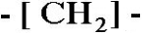 | 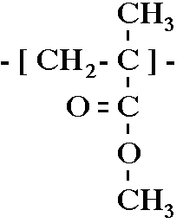 | 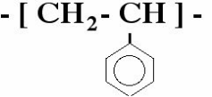 | 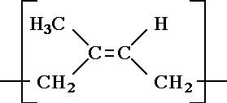

(5) Polymer conformations

5.1 Models for the conformation of polymers

In order to understand the properties of most substances, we must consider a large assembly of molecules. In the case of polymers, however, the molecules themselves are very large and due to their flexibility they can take up an enormous number of configurations by rotation of chemical bonds. The shape of the polymer can therefore only be usefully described statistically and one need to use statistical mechanics to calculate the characteristics of even an isolated polymer. To be able to investigate the properties of a single polymer and to neglect interactions between polymers, the polymer is placed in a very dilute solution. In this chapter, we will theoretically investigate the properties of an isolated, single polymer chain in solution (which in addition is linear and consists of only one kind of monomers).

5.2 Freely-jointed chain
Many polymers are highly flexible and are coiled up in solution. In a simple model we thus describe a polymer as consisting of a large number of segments freely joined up, where all angles between segments are assumed to be equally likely.

The momomers are located at positions Rj and connected by bonds 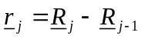 of length 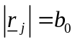.The end-to-end vector is 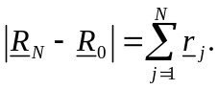 At any instant, the configuration (arrangement) of the polymer is one realisation of an N-step random walk in three dimensions. In time, the various segments undergo Brownian motion and the polymer fluctuates between all possible configurations of the random walk | 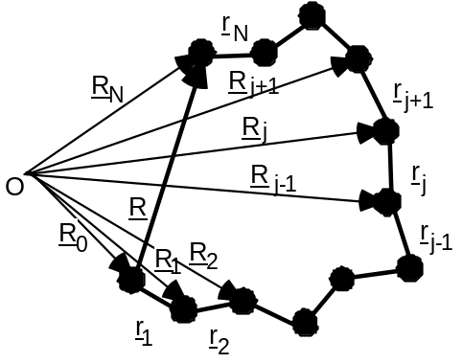
.
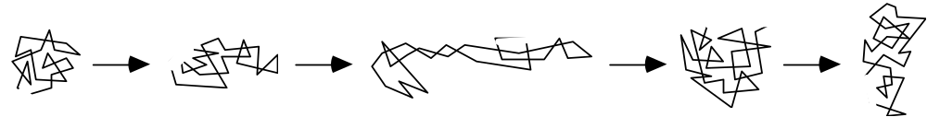

Size and shape of a freely-jointed chain:
Based on the end-to-end vector R, the size and shape of the chain can thus be described probabilistically:

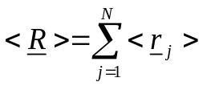
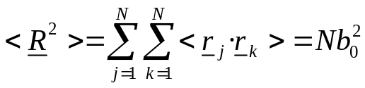
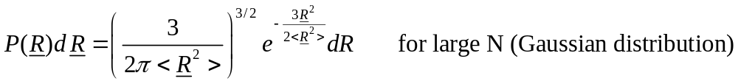
While the end-to-end distance represents a well-defined quantity for a linear chain, we need a more versatile measure of the size for more complicated architectures, such as branched or star-shaped polymers. This is provided by the mean square distance from the centre of mass RG, the so-called radius of gyration Rg, which is also a measure of the extension of a (random) chain:
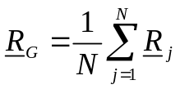
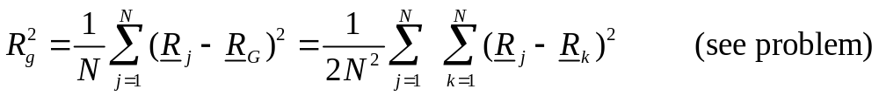

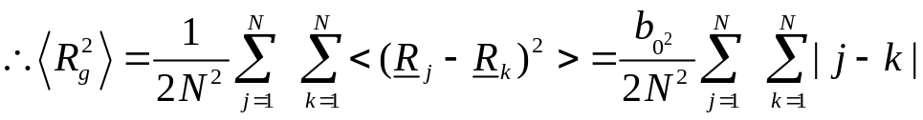

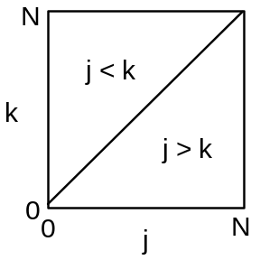
Now transform to continuous variables
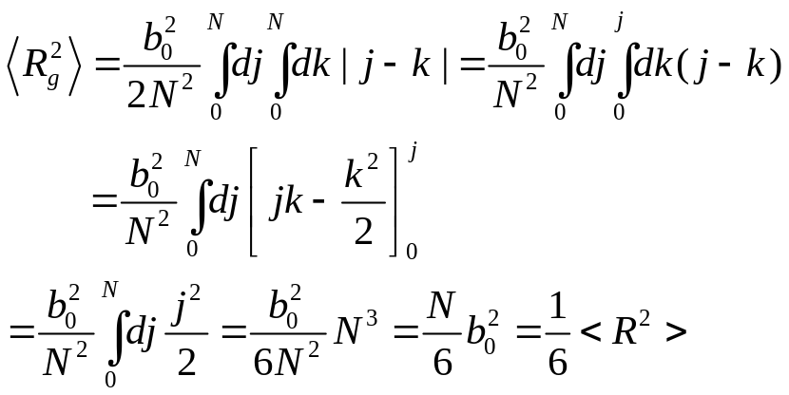

Thus we find the simple result that the mean squared gyration radius is proportional to the mean squared end-to-end distance.

5.3 Freely-rotating chain

In a polymer molecule the bond angles are usually restricted, which leads to a limited flexibility of the molecule.

Let us consider the case of n-butane:
H3C - CH2 - CH2 - CH3
While the C-C bond angle is fixed at about 120°, rotation about the bond is possible.
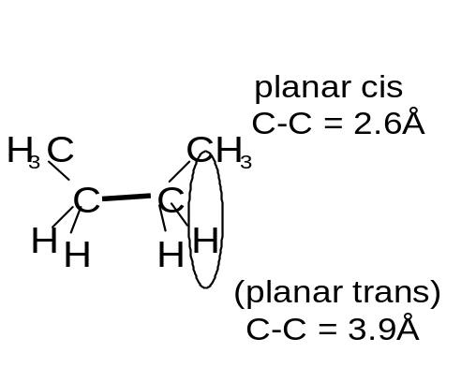

Nevertheless, the potential energy of a configuration depends on the valence angle:

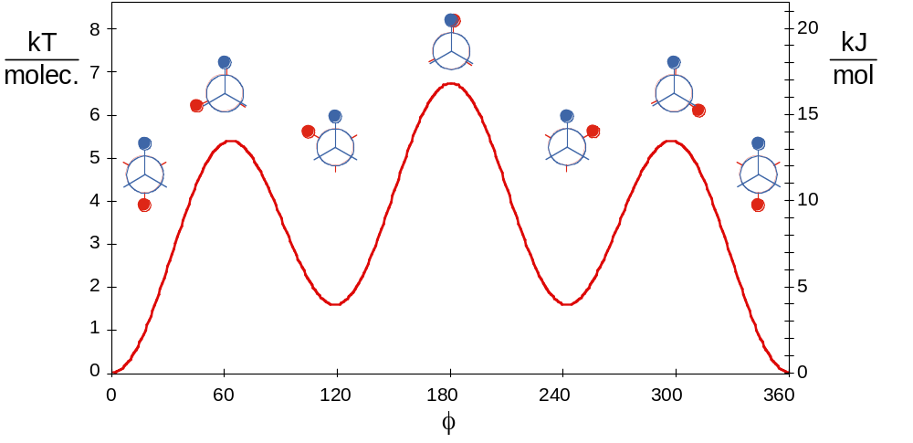
At low temperatures (kBT < config. energy) the configuration will thus be predominantly trans. As the temperature is increased (kBT ~ config. energy), there will also be gauche configurations and at high temperatures (kBT >> config. energy), any angle will be possible. This suggests that a model should be based on fixed angles between bonds, but free rotation about the bonds. This model is called the freely-rotating chain.

We start with a fixed configuration of r₁, r₂, ...., r_{j-1} and then add the next segment r_{j}. While the bond angle Θ is given by the chemistry of the molecule, the segment can still freely rotate about the axis defined by rj-1, i.e. ϕ can take any value 0≤ϕ≤2π. If we average rj over ϕ, while keeping r₁, r₂, ...., r_{j-1} fixed, only the component in rj direction remains:
<rj>r₁, r₂, ...., r_{j-1} fixed = cosΘ r_{j-1}
For the calculation of <R2> we also need <r_{j}·r_{k}>,

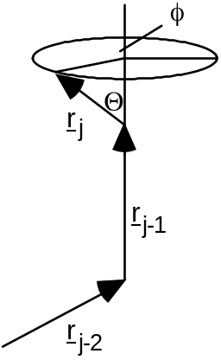

which we obtain by multiplying both sides with r_{k} and taking the average:
Since cosΘ< 1, correlations between r_{j} and r_{k} decrease with increasing distance
|j-k| between the links and the orientations of distant links become uncorrelated.
The end-to-end distance <R2> of a freely-rotating chain is hence
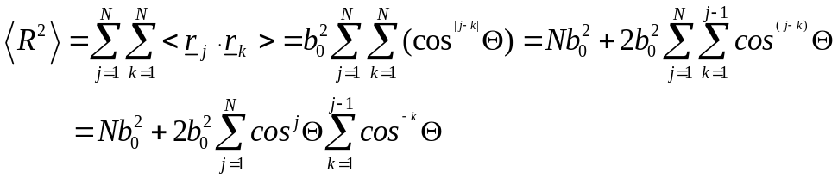
where we used the same argument as above to deal with |j-k|. To calculate these two sums we consider the geometric progression:

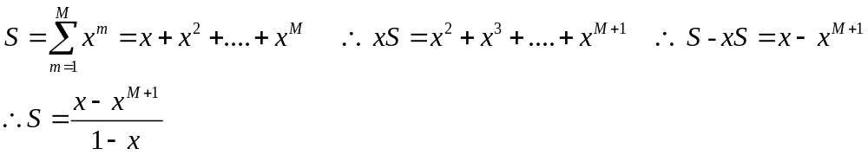
With the help of this formula we get
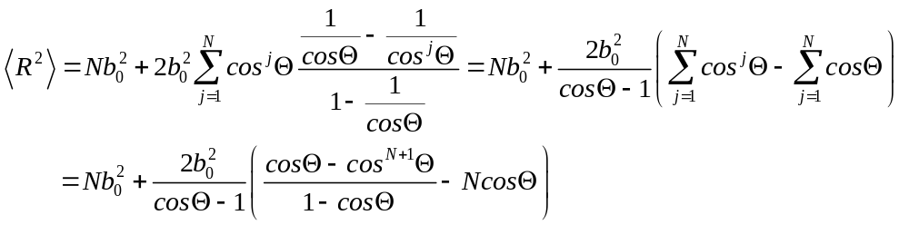
For large N this can be simplified

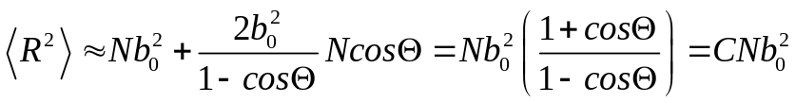
with C = (1+cosΘ)/(1-cosΘ). To get a better idea of the effect of a fixed angle Θ, i.e. going from a freely-jointed to a freely-rotating chain, we look at a few special (but not necessarily very realistic) cases:

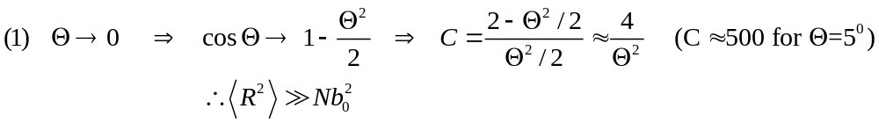
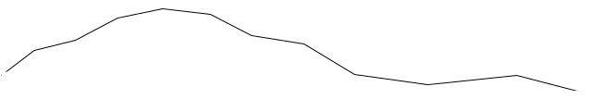

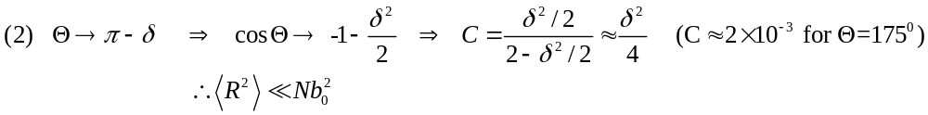
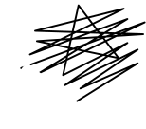

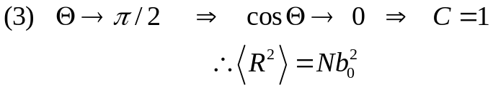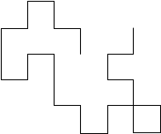

Again, we get <R2> ∝ N, which suggests that a long freely-rotating chain can be represented by an equivalent freely-jointed chain with N' segments of length b. Real and effective chain must have the same actual length (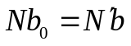) and the same end-to-end distance <R2> i.e. (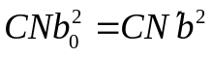). These constraints result in b = Cb₀ and N' = N/C. This has important consequences:

• All sufficiently long flexible chains have identical behaviour as regards their dimensions: the chemical details are hidden in N' and b.
• While individual monomer pairs are not totally flexible, groups of monomers are
• C represents the number of monomers over which the orientational correlation is lost
• b is the so called “Kuhn” statistical segment length (and twice the “persistence length” l_{p} )
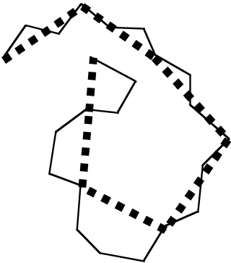

5.4 Excluded volume effects
The fact that two monomers cannot occupy the same space has consequences on different length scales. On a local length scale this prevents neighbouring monomers from coming too close together. This effect is taken into account in terms of a restricted bond-angles, which prevents them from overlaping. Non-overlap, i.e. excluded volume, of distant monomers along the chain has also to be taken into account and can have surprisingly large effects.

To estimate the importance of this effect, we consider the fraction of coil volume actually occupied by monomers:
volume actually occupied by monomers: 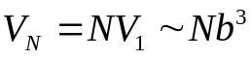
(where V1 is the volume of a monomer)
volume occupied by the whole coil: 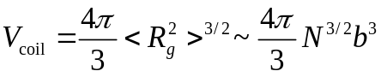
∴ 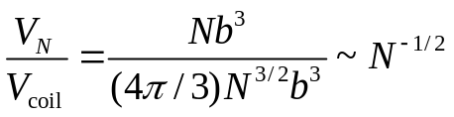
e.g. N = 104 monomers occupy only about 1% of the whole coil volume.

The overall chain size <Rg2>1/2 is determined by the competition of two effects. Entropy (and chain connectivity) favour a compact chain and avoid the more unlikely stretched configurations, while repulsive excluded volume interactions want to expand the chain to avoid overlap. Based on this balance we will 'calculate' the effect of excluded volume in a very hand-waving way. (Due to a fortuitous cancellation of errors introduced by various approximations, the result is practically identical to more rigorous treatments, which are very involved.)
We consider the Helmholtz function of a single chain, which is regarded as an assembly of particles with constant volume NV1 at constant temperature T:
F = U - TS
The entropy S is given by
S = kB ln(no. of configurations)

where for a given R the number of configurations is expected to be proportional to
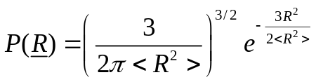
and hence
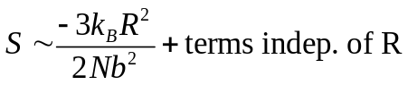
The internal energy U includes the kinetic and potential energy. However, the kinetic energy is independent of the configuration and thus of R and we only have to consider the potential energy. To estimate the potential energy, we disregard the connectivity of the chain and calculate the interaction energy of a 'segment gas' confined in a volume R3. The probability of a monomer to lie in this volume is given by the fraction of total coil volume occupied by monomers, which we estimated above to be 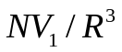. Thus the probability of monomer-monomer contacts
is 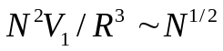. With an energy ε of a monomer-monomer contact, the potential energy 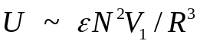.
We thus obtain
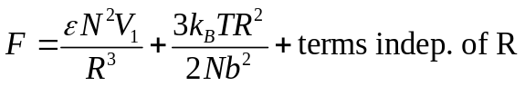
which can be minimized with respect to R, i.e. dF/dR = 0, yielding
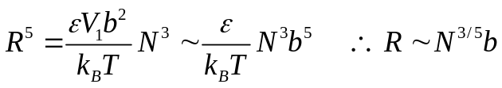
Simulations give a very similar scaling, R ~ N 0.588. The chain can no longer be modelled by a random walk, but has to be described by a self-avoiding random walk. The distribution of end-to-end distances is also not Gaussian.
Although the difference between an exponent of 0.5 (as is characteristic for the freely-jointed and freely-rotating chains, i.e. a random walk) and 0.6 (excluded volume chain, i.e. self-avoiding random walk) seems small, it has a large effect at large N. For example, for N = 104, R = N0.5b = 100 b, while R = N0.6b = 251 b, which corresponds to a swelling of the chain by a factor of 2.5.

5.5 Good, poor and theta solvents
So far we only considered monomer-monomer interactions, which we assumed are purely repulsive, and neglected the influence of the solvent. However, the type of solvent has a great effect on the polymer size. If there is a high affinity with the solvent ('good solvent') the polymer swells, while it will shrink in a 'poor solvent'. We consider a lattice model, where each lattice site has z nearest neighbours and

there are Ns solvent molecules, Np monomers and Nsp solvent-monomer contacts. The energies of interaction are εss for solvent-solvent, εpp for monomer-monomer and εsp for solvent-monomer interactions.
Then the energy of mixing ΔUmix is given by
ΔUmix = U - (Us + Up)
where energy of pure solvent 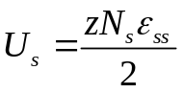
energy of pure polymer 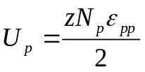

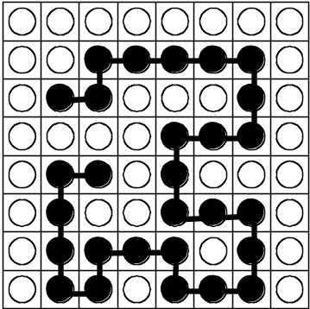

energy of solution 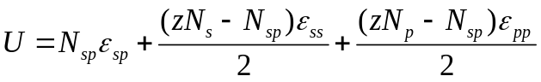

Hence we obtain for the energy of mixing
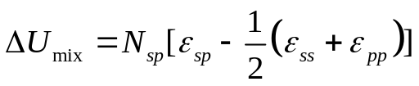
which can be either positive or negative:
• 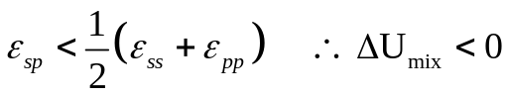
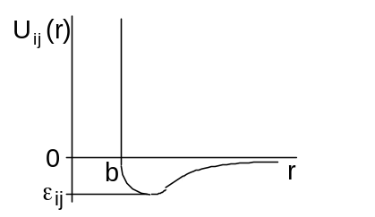

This is the case of a 'good solvent', because the monomers prefer to be near the
solvent molecules. Excluded volume effects then expand the chain.
• 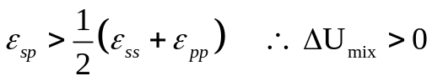
This is the case of a 'poor solvent', because the monomers prefer to be near to
each other (and similarly for the solvent molecules). The attraction between the
different monomers offset the excluded volume effect.
The importance of the attractions generally depends on temperature. At very high temperatures the coil is expanded and the solvent quality is good. In contrast, at very low temperatures, the solvent quality is poor, attraction dominates, the coil collapses and phase separation is observed. In between these two limits, there is a temperature, the so-called theta temperature Θ, where the coil has ideal dimensions and the effects of excluded volume and attraction cancel each other. The solvent at T = Θ is called a 'theta solvent'. The stronger the attractions the higher Θ will be, while for weak attractions Θ is low.
A full treatment of the coil expansion is rather involved and has to take into account excluded volume, attractions, configurational entropy and entropy of mixing.

Summary
A polymer has characteristics on different length scales. On a very global length scale, it has a molar mass M and an overall size which can be characterised by the root mean square end-to-end distance <R2>1/2 or radius of gyration
<Rg2>1/2 ∝ Nν ∝ Mν, where ν = 1/2 for a freely-jointed or freely-rotating chain (random walk) and ν = 3/5 for an excluded volume chain (self-avoiding random walk). On a smaller length scale the behaviour will be dominated by the finite flexibility or 'persistence' of the chain, which is characterised by the Kuhn length b. The chain will essentially behave like a stiff rod on this length scale. This rod typically has a constant mass per length, M/L, and thus M α L. Finally, the local cross-sectional structure will be observed on an even smaller length scale.

(6) Concentrated polymer solutions

Previously we considered a single polymer in a very dilute solution. Now we increase the concentration in steps until we reach bulk polymers. A special aspect of bulk polymers will then be discussed in more detail in the following chapter. The most important regimes of concentration are:

(A) Dilute:

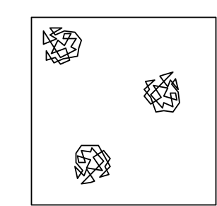

The polymer coils are well-separated on average. 'Dilute' means:

concentration in
mass per volume
↓
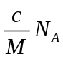 | × | 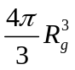 | << 1
number per volume |  | volume of  one coil
volume fraction of coils

(B) Overlap concentration c*:

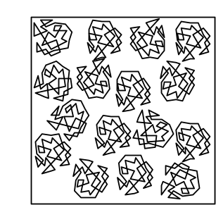

Overlap occurs when the volume fraction of coils reaches unity and thus
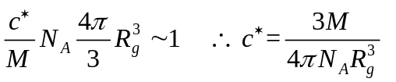
using Rg = <Rg2>^{1/2} = B Mν gives
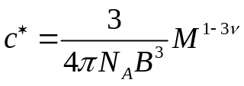

Example: Polystyrene with M = 106 g mol-1 in a good solvent (ν = 0.6) and
B = 0.028 nm (g mol-1)-0.6 leads to c* = 0.29 kg m-3 = 0.29 mg/ml. With the density of polystyrene ρ = 1050 kg m-3, the volume fraction of monomers is c*/ρ = 0.28×10-3. c* can be very small for large polymers.

(C) Semi-dilute:

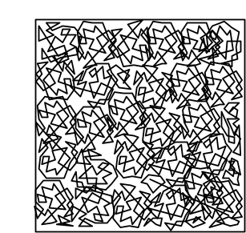

The concentration is larger than the overlap concentration c*, but still much smaller than the bulk density. The coils interpenetrate and entangle, but the solution is still mostly solvent

(D) Concentrated:
In this case the concentration is very close to the bulk density and the polymer monomers occupy a significant fraction of the total volume.

(E) Bulk polymers:
Bulk polymers are divided into two main classes, characterised by whether they are cross-linked or not. There are elastomers or rubbers with a low degree of cross-linking and thermosets with a high degree of cross-linking. We will investigate the behaviour of rubbers in the next chapter. The second class are thermoplastics, which are not cross-linked. Most everyday plastic products are thermoplastics. We will briefly discuss their behaviour upon cooling, which shows similarities to the behaviour of colloids.
At high temperature the free energy is dominated by the entropic terms. The melt resembles a random assembly of mobile, intertwined, flexible coils with a density similar to the density of the corresponding monomer liquid. Upon cooling the potential energy takes over and the bonds are restricted in their rotation leading to configurations which are more straightened out. Below the melting temperature Tm, a crystal is the lowest free energy state. Crystallisation, however, requires significant ordering of the initially random melt and is only possible if cooling occurs slow enough. If the melt is rapidly cooled below the glass transition temperature Tg (< Tm), then instead of a crystal a glass is formed, which represents an amorphous metastable, but long-lived state. Although the polymers can still vibrate, they can no longer move. Solid thermoplastics are frequently a mixture of crystalline and amorphous structures.

Part 3: SURFACTANTS

(7) Surfactants

7.1 Structure and examples
In this chapter we discuss the behaviour of a special class of molecules. In these

molecules one end contains a 'hydrophilic' (water-loving) part, while the other end is 'hydrophobic' (water-hating). They are called 'amphiphilic' (loving both) molecules, which reflects their structure, or 'surfactants' (from SURFace ACTive AgeNT), which refers to their behaviour in solution.
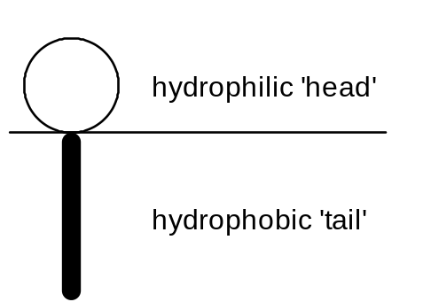

A few chemical structures are shown below. They illustrates that the hydrophobic tail usually consits of hydrocarbon chains of different lengths and that the hydrophilic head might either be positively or negatively charged, zwitterionic or uncharged.
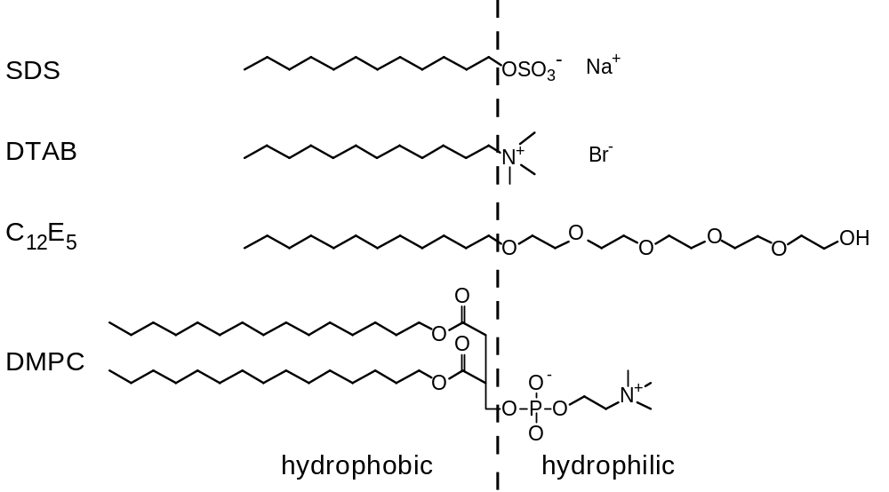

The hydrocarbon chains are insoluble in water. The molecules are thus preferentially located at the surface, which allows the hydrophilic head to be surrounded by water and the hydrophobic chains to avoid contact with water. There is always an equilibrium between surfactants at the surface and in the bulk of the

solution. The coverage of the surface leads to a reduction of the surface tension with increasing surfactant concentration.

(8) Self-assembled structures

8.1 Introduction
Above a so-called critical micellar concentration (cmc) surfactants self-assemble in solution spontaneously into larger structures. (In the following we will consider aqueous solutions, although the arguments also apply to other polar or non-polar (organic) solvents.) This allows the hydrophobic parts to crowd together while

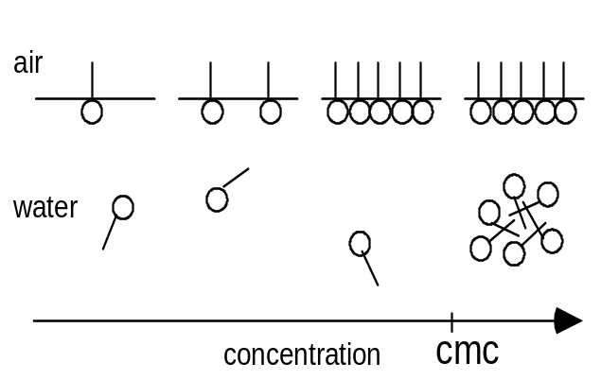

being 'shielded' by the hydrophilic heads. The density of the hydrophobic cores is very similar to the density of fluid hydro–carbons and the random arrangements of the chains resemble closely a fluid structure.

The surfactant assemblies are not held together by chemical bonds, but only by weak interactions (<kBT). Their existence and properties are thus determined by a delicate balance between different effects, such as the transfer of hydrophobic chains into the core, interactions between the head group and the entropy of mixing. Small changes in control parameters, for example temperature, salt concentration or pH, thus have large effects on the characteristics of the surfactant aggregates. Nevertheless, for given conditions, they have very well-defined properties (shape, size etc.).

8.2 Shape of surfactant assemblies
Surfactants spontaneously self-assemble into a variety of different structures. We use geometric or 'packing' considerations to understand and predict the shape of surfactant aggregates. In this model the geometry of a surfactant molecule is described using the following parameters:
- optimal headgroup area a0: As discussed in the previous section, this depends on a delicate balance of forces and is thus not only controlled by the 'chemistry' of the surfactant molecule, but also depends on different control parameters of the solution, such as salt concentration, pH or temperature.

- volume v of the hydrophobic part: The hydrophobic part usually consists of hydrocarbon chains and for saturated hydrocarbons the volume v can be approximated by
v ≈ (27.4 + 26.9n)×10-3 nm3
where n is the number of carbon atoms.

- critical chain length lc: The maximum effective length of the hydrophobic chains is called the critical chain length lc, which has to be shorter than the fully extended molecular length of the chain lmax. For saturated hydrocarbons the critical length can be estimated using
lc <lmax ≈(0.154 + 0.1265n) nm

The critical chain length heavily depends on the 'chemistry' of the molecule, for example on the presence of double bonds or branching, as well as the temperature.

The structure which will be adopted is determined by a balance between entropy, which favours small aggregates, and energy considerations: A certain shape or size might only be possible by imposing a headgroup area a > a0, which is energetically not favourable. We will now establish the criteria for the different shapes.

(A) Spherical micelle:

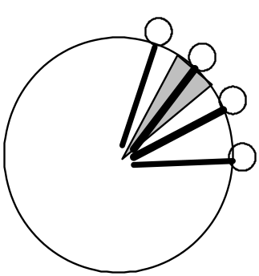
For a spherical micelle with aggregation number N, the total volume and surface area are given by
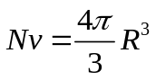
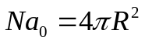
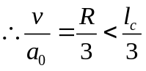

where we used the fact that the radius R cannot be larger than the critical chain length lc. We thus obtain for the critical packing parameter P
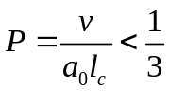
(B) Cylindrical micelles:

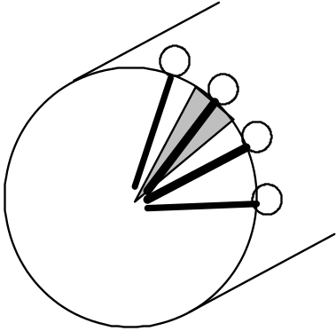

For a cylindrical micelle the total volume and surface area are given by
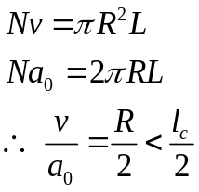
again using R < lc.

We thus obtain for the critical packing parameter P
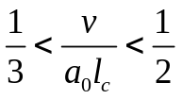
Below the lower limit spherical micelles are formed.

(C) Bilayers:

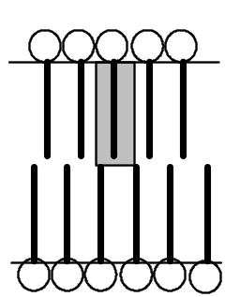

For a bilayer the total volume and surface area are given by
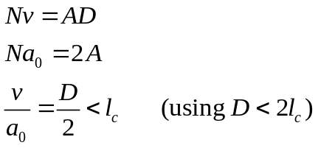

We thus obtain for the critical packing parameter P
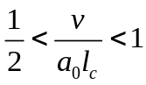
Below the lower limit cylindrical micelles are formed.

Part 4: Glasses

Many fluids, whether simple liquids like argon or complex liquids such as colloids and polymers, can be quenched to temperatures well below their equilibrium freezing point without crystallization occurring on experimental timescales. In thermodynamic terms this is interpreted as a failure of the system to reach its true equilibrium (minimum free energy) state, namely the ordered crystalline phase. Such out-of-equilibrium systems are known as glasses. In terms of their structure (eg as measured by a radial distribution function, g(r), they are practically indistinguishable from a liquids, i.e. they exhibit some short ranged order, but no long ranged order. However, their dynamic behaviour is quite different from that of liquids; glasses exhibit very slow relaxation because molecules cannot easily diffuse. As a result, glasses do not flow (on experimental timescales) and therefore their mechanical properties, i.e. their response to stress and shearing, is more akin to that of solids.

(9) Glass forming systems

Glasses may be formed if the cooling rate is so fast that the liquid does not have time to crystallize , or alternatively because the molecules have some feature to their structure or bonding that inhibits the formation of a crystalline phase. Many glass forming materials are found in nature. Below we describe just a few.

Elements: Sulphur, Selenium and Phosporous readily form glasses.
Metallic alloys: liquid metals can form glasses if quenched very rapidly (10⁶ K s⁻¹). Such glasses find applications in recording heads and electrical transformers.
Polymer glasses: Due to entanglement effects, polymers form glasses very easily. Examples from everyday life are polycarbonates (eyeglasses, shatterproof windows) and polymethacrylate (plastic pipes and tubes).
Oxide glasses: Familiar examples are SiO₂ , Na₂O and CaO (all components of window glass).
Organic glasses: Sucrose solution forms a glass used in boiled sweets. Toluene and methanol also readily form glasses.

(10) Relaxation time and viscosity

Let us first consider relaxation in liquids. We have already seen that at high volume fractions a particle is effectively trapped by its nearest neighbours, within a ‘cage’. To escape the cage, a particle must jump. Let us now consider the characteristic time τ between such jumps and its dependence on temperature. Empirically, one finds that
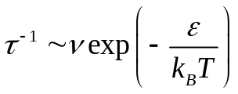

Here ν is the typical vibration frequency for a particle rattling around in its cage. This can also be regarded as the frequency with which the particle attempts to escape its cage. The probability of an escape attempt succeeding depends on a Boltzmann factor, i.e. the exponential of the ratio of the energy cost associated with climbing the cage “walls”, ε, to the typical thermal energy k_{B}T.

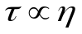It can be shown (cf. PH10002) , that the relaxation time τ is proportional to another quantity, the viscosity η, which is a measure of the response of a material to a shear stress, or more loosely speaking a measure of the ability of a liquid to flow. Thus and it follows that
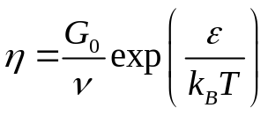

where G₀ is a proportionality constant. This characteristic exponential temperature dependence is known as Arrhenius behaviour. Loosely speaking the viscosity provides a measure of the ability of a liquid to flow.

While Arrhenius behaviour is observed for the viscosity of liquids at high temperature, things are very different at low temperature. The experimentally measured viscosity and the associated configurational relaxation time exhibits a temperature dependence that strongly departs from that implied by the characteristic frequency of vibrations ν
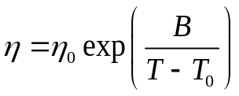

The empirical finding, known as the Vogel-Fulcher law implies that the viscosity diverges exponentially at the finite temperature T₀. In practical terms, this means that as T₀ is approached from above, one reaches some temperature T_{g} (the glass transition temperature) at which the time for a configuration to relax becomes comparable to the timescale of the experiment itself τ_{exp}. At this point, the system falls out of equilibrium with respect to rearrangements of the particle configurations.

Characterising the glass transition

The glass transition temperature T_{g} is that temperature at which the system falls out of equilibrium on the experimental timescale τ_{exp}. Clearly therefore, if one does a long experiment, in which the temperature is lowered slowly, the system will have a greater time to relax at each successive temperature and will stay in equilibrium to a lower temperature. Thus the experimental glass transition temperature depends on the rate at which we do the experiment. To illustrate this consider a measurement of some structural quantity (such as the sample volume) as a function of temperature. Various scenarios for the behaviour of the volume as the temperature are shown in the following figure

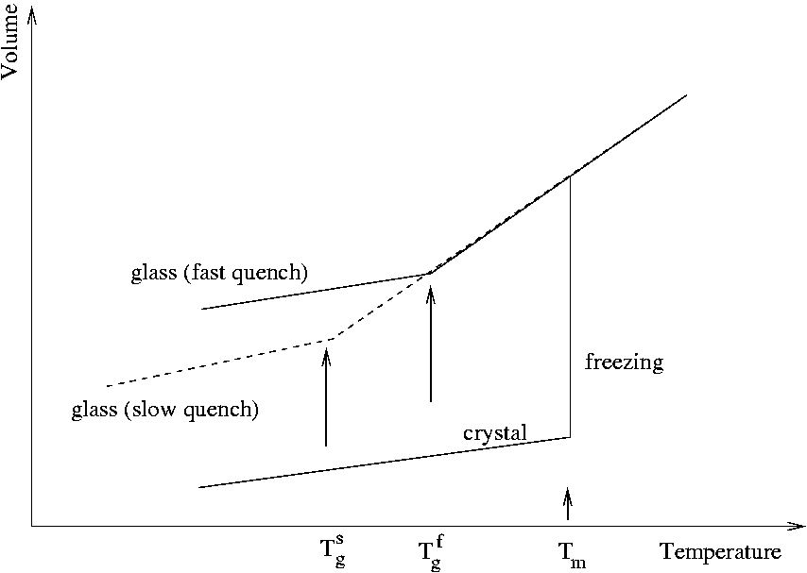

At the glass transition temperature, the curve exhibits a well defined discontinuity in it slope, rather like what happens at an equilibrium phase transition such as freezing or boiling. The reason why the glass transition is not a true thermodynamic phase transition is that the temperature at which the discontinuity occurs depends on the history of the sample, i.e. how rapidly it is cooled. We say that the glass transition is a kinetic phase transition brought on by the divergence of the structural relaxation time.

A simple picture of the glass transition

Theories of the glass transition are a matter of intense current research and it is probably fair to say that the detailed physics is still not well understood in a comprehensive fashion. Nevertheless simple models offer some insight, in qualitative if not quantitative agreement with experiment. One such theory is based on the idea of cooperativity. In a liquid at high temperatures, a molecule can diffuse simply by moving to occupy the space made available by the random local motions of its neighbours. At low temperatures and high volume fractions, the local motion of neighbours is insufficent to allow diffusion. Instead a number of neighbours must move cooperatively in order to make space for a molecule to move. The minimum number of molecules that have to move in unison in order for diffusion of a molecule to take place gives rise to the concept of a cooperative rearranging region. As the temperature is lowered the size of this region increases, diverging (with the viscosity) at the Vogel-Fulcher temperature T₀

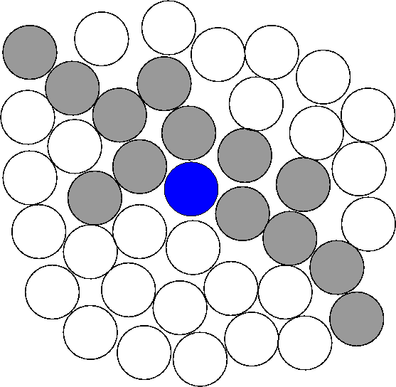
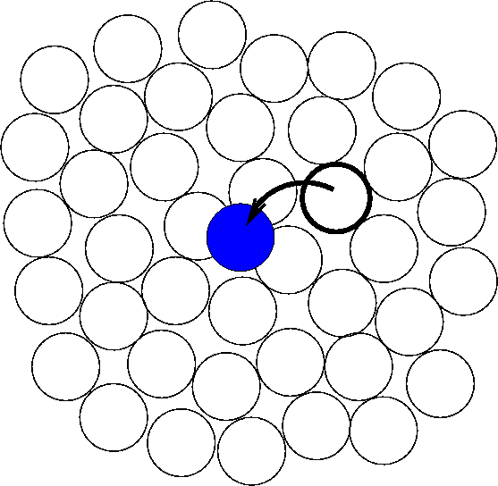

If we suppose that the energy barrier for a single molecule to move is μ and there are z molecules in the cooperatively rearranging region, then the thermal activation barrier for motion is
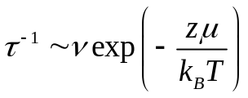

with ν the microscopic vibration frequency. Within this model, the non Arrhenius behaviour of the relaxation time (see above) derives from the increase in the number of molecules that have to move cooperatively as temperature decreases, i.e. the T dependence of z.

.

Literature

The best overall text is: R.A.L Jones, Soft Condensed Matter, Oxford University Press. Shelfmark [539.2 Jon].
Additionally, the following more specialised texts should also be useful. They can be found in the University Library under the stated shelfmark.

Colloids
(1) D.F.Evans, H.Wennerström: The Colloidal Domain - Where Physics, Chemistry, Biology, and Technology Meet. VCH Publishers (1994). [541.18 Eva]
(2) R.J.Hunter: Introduction to Modern Colloid Science. Oxford University Press (1993). 541.18 Hun]
(3) W.B.Russel, D.A.Saville, W.R.Schowalter: Colloidal Dispersions
Cambridge University Press (1989).[541.18 Rus]
(4) D.H.Everett: Basic Principles of Colloid Science.
Royal Society of Chemistry Paperbacks (1988) [ 541.18 Eve]

Polymers and surfactants
(1) R.J. Young and P.A. Lovell: Introduction to polymers [678 You].
- M. Doi: Introduction to polymer physics [541.64 Doi]
- J.Israelachvili, Intermolecular and Surface Forces, Academic Press (1992), Chs. 16 and 17

Glasses
(1) J. Zarzycki; Glasses and the vitreous state. Cambridge University Press (1991).

PH30028: Soft Condensed Matter Physics
Problem sheet

- Relaxation time in atomic fluids
Spherical colloidal particles of radius 30 nm and density 1.35 g cm⁻³ are suspended in water (temperature 25°C, density 1.0 g cm⁻³, viscosity 1.0×10⁻³ Pa s). Calculate the average distance from the origin along a given axis travelled by a particle in 1 minute due to Brownian motion and sedimentation, respectively. What are the displacements after 1 hour?

- Equipartition
The equipartitioning theorem states that in thermal equilibrium each generalised co-ordinate which occurs in the total system energy only as a quadratic term contributes (1/2)k_{B}T to the mean energy of the system. Use the theorem to estimate the typical time it rakes atoms (or small molecules) in an atomic liquid to move distances of the order of their own size, i.e. estimate the relaxation time.

- Gravitational length
- Find the typical length scale (`gravitational length’) of the distribution of polystyrene particles (density ρ_{p} =1.05×10³ kg m⁻³) of radius 50 nm and 1μm respectively, suspended in water (density ρ_{w} =1.00×10³ kg m⁻³, viscosity 1.0×10⁻³ Pa s) at room temperature. Hint: The gravitational length is the height at which the concentration falls to 1/e of its greatest value.

- If a container of height H=4cm contains a dilute suspension of these particles at an average concentration of n_{a} particles per unit volume, what are the actual concentrations (in terms of n_{a}) at the top and bottom of the sample when sedimentation equilibrium has been reached.
- If the above sample is shaken up to give an initially uniform concentration and then left undisturbed, estimate how long it will take the concentration profile to reach its equilibrium state (A surprisingly long time!)

- Peclet number
A definition of a colloid is a particle small enough that its Brownian motion is not dominated by gravity. Thus if the particle is raised a distance equal to its radius, the increase in its gravitational potential energy must be less than the thermal energy (3/2)k_{B}T. Another measure of the relative importance of the effects of Brownian motion and gravity, is the Peclet number Pe=τ_{R}/τ_{sed}. Here τ_{R} is the time taken by a particle to diffuse a distance equal to its radius, and τ_{sed} is the time taken by it to sediment the same distance. When Pe << 1, Brownian motion dominates; when Pe >> 1, gravity dominates. Show that the condition Pe<1 is more or less equivalent to the definition of a colloid given above.

(5) Diffusion equation
Prove by direct substitution that 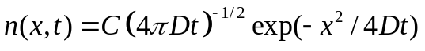 is indeed a solution to the 1D diffusion equation 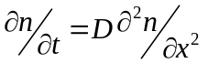.
Discuss the meaning of the constant C.

- Mean square displacement
Starting from the diffusion equation, deduce the mean square displacement, 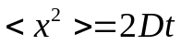, without using the full solution to the diffusion equation.
Note that n(x,t) is the number density, from which the probability density of finding a particle in the region [x,x+dx] during the time interval [t,t+dt], can be obtained by normalising with . Having this in mind, the mean square displacement is

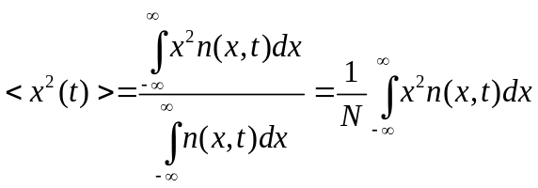
Hint: Multiply both sides of the 1D diffusion equation by x² and integrate by parts over x to get an o.d.e for < x²> with t as the independent variable.

- Relaxation time in colloidal suspensions
Use 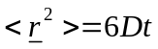 and the Stokes-Einstein relation to show that the time τ_{R} for a particle to diffuse its own radius R, scales as R³. The relaxation time τ_{R} is a good estimate for the time taken to return to equilibrium after a disturbance. Estimate τ_{R} for a suspension of spheres of radius R≈1μm, i.e. at the upper limit of the colloidal size range.

- Colloidal crystals
Colloidal crystals are observed for volume fractions φ between 0.545 and 0.74. Show that the upper limit of φ=0.74 corresponds to the closest packing in a fcc crystal. What is the average distance between the colloidal particles for the lower limit φ=0.545? Hint: to get the average consider a simple cubic lattice of the same volume fraction

- Lagrange’s expression for the radius of gyration
For N equal point masses at positions 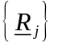, the radius of gyration is defined by
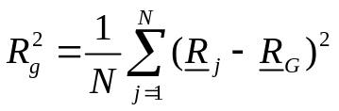 where is the position of the centre of mass. Show that
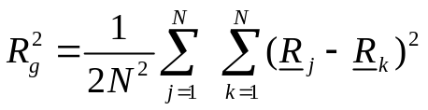 Hint: Note that 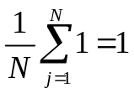

- Mean length
Calculate the mean end-to end length of a freely jointed polymer consisting of 10⁵ monomers of length 4.322 Å. How does the end-to-end length change if the valence angle of the chain is fixed at 108 º?

- Real data
Light scattering measurements on dilute solutions of polystyrene, of different molar masses M, at the theta temperature give the following results for the mean square radius of gyration 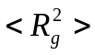:

M (10⁶ g mol^{–1}) | 4.04 1.56 1.20 1.06 0.626 0.394
(nm²) | 3260 1210 928 770 484 305

- Show that these results are consistent with 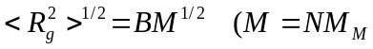 where N is the number of monomers in the chain and M_{M} is the molar mass of one monomer; M_{M}=100 g mol⁻¹) and estimate the value of B.
- Given that the `size’ of a styrene monomer is about b₀=0.23 nm, calculate the factor C which represents the effect of restricted bond angles in 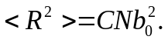 From C, calculate the bond angle θ which would apply if polystyrene can be represented by a freely-rotating chain. [Remember 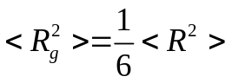]
- Calculate 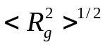 for a polystyrene chain of molar mass 1×10⁷ g mol⁻¹ at the theta temperature.
- For the chain of (c), estimate the fraction of the volume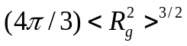 which is actually occupied by styrene monomers (assume that the density of styrene when polymerised is about 1g cm⁻³). What is the overlap concentration c* (in mass per volume)? How do you expect c* to change upon an increase (decrease) in temperature?

- Micelles
The volume of a linear hydrocarbon chain with n carbon atoms is given by v=(27.4+26.9n)×10⁻³ nm³, and its critical chain length is l_{c}=(0.154+0.1265n) nm. An amphiphile has an anionic head group with an optimum head group area in aqueous solution of a₀=0.65 nm².
- What shape micelles are formed by amphiphiles with linear hydrocarbon chains having n=10?
- What is the average size and aggregation number of each micelle?

- Viscosity
For polystyrene, the variation of viscosity with temperature follows the Vogel-Fulcher law B=710 and T₀ =50°C. Plot the function η/η₀ in the temperature range 80-150°C. By what factor does the viscosity and relaxation time vary between the temperatures of 100-140°C?

- The glass transition
For polystyrene, a relaxation time associated with configurational rearrangements, τ_{config}, follows a Vogel-Fulcher law,
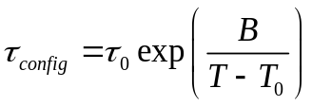

Where τ₀ , B=710 and T₀ =50°C are constants. A value of the experimental glass transition temperature is measured with an experiment carried out at an effective timescale τ_{exp}= 1000s and found to be 101.4°C.

- Another experiment is carried out at an effective timescale of 10⁵ s. What is the value of the glass transition temperature obtained from this experiment?
- On what timescale must an experiment be carried out if it is to measure a glass transition temperature within 10°C of the Vogel-Fulcher temperature T₀. Is this practically possible?

